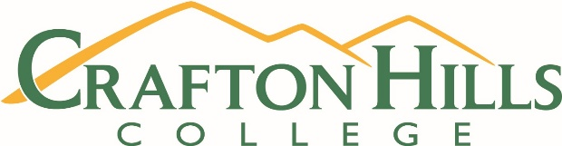

Crafton Hills College & Valley College
Child Development Training Consortium
Fall ‘19 Joint Advisory Committee Meeting
18 October 2019
Minutes

- The meeting began at 11:30. Lunch was served and the welcome and introductions began.
- General information about the Child Development Training Consortium was shared as well as the purpose and responsibilities of the Advisory Committee.
- SBVC shared information about new certificates and degrees they are working on (Children and Trauma), proposed changes to the Matrix and department goals and directions. They also distributed the new SBVC Child Development Brochure.
- Discussion of increasing the education about the workforce registry and including that in our coursework.
- Since we include the Mentor program as part of this meeting, Kellie Barnes gave an overview and update of the mentor program.
- CHC provided a general update about the struggle with getting students to apply for the funds, looking at consolidating some of the specialized curriculum and is continuing to offer CD 105 at the Redlands High School.
- Eligibility Priorities were approved by the Advisory Committee
- Student Payment Policies for SBVC and Crafton were approved by the Committee.
- Next meeting will be in the fall.
- Meeting adjourned at 1:45 pm.

